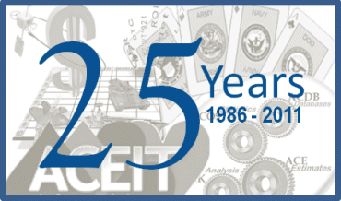

**2011 ACEIT USER WORKSHOP  
 25 Years of Cost Estimating Innovation**

**Abstract Submission Form**

Paper Title:

Author(s):

Author’s Job Title(s):

Company/Organization:

Address:

Phone Number:

Fax Number:

E-mail Address:

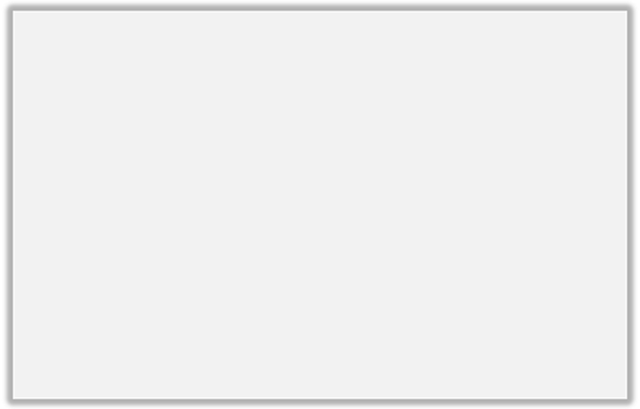

Paper/Presentation relates to ACEIT application(s):

ACE - cost estimate development and documentation

POST - charting and tabular reports

ACDB - database development, search, and retrieval

CO$TAT - statistical analysis / methodology development

Librarian - methodology library/custom inflation indices creation

KnWS - browser-based enterprise knowledge management system

Paper/Presentation relates to the following subject(s):

Cost Estimating  ACE Plug-ins

Parametrics  Innovative uses for DECs

Risk Analysis  Estimate Review Strategies

Risk Management  ACEIT Tricks & Tips

Budget Management  Time Phasing Strategies

Inflation  Integrated tools (CO$TAT and Inflation Utility)

 Linking ACE to other tools  Joint Cost & Schedule Uncertainty

POST Reporting  Analysis of Alternative Strategies

Cost Benefit Analysis Implementations

Prospective presenters should complete this Abstract Submission Form and send it along with the abstract and author’s biography to the Workshop Coordinator, Trina Rodriguez, by 01 October 2010.

E-mail: ACEIT_Sales@tecolote.com

Fax: (281) 333-0232

Mail: Tecolote Research, Inc.

Attn: Trina Rodriguez

1322 Space Park Drive

Suite A246

Houston, TX 77058

If your paper is selected to be presented at the 2010 ACEIT User Workshop, you will need to sign a release agreement allowing Tecolote to use your paper in its various publications.



**Author’s Biography:**

**Abstract:**